Hip Arthroscopy
Rehabilitation

Physiotherapy information and advice

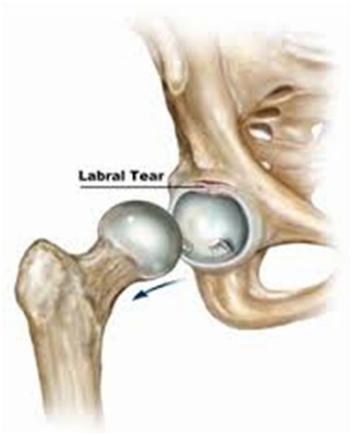

General Advice

Your stay is usually as a day patient

The exercises vary according to the intervention during your operation Generally you will be given crutches to help you mobilize

The hip is often more painful the day after surgery, this is due to the anaesthetic inside the hip wearing off

Take the pain relief as prescribed for you, this will help you to exercise more comfortably

On discharge from hospital you will be referred for out-patient physiotherapy. This will be arranged close to where you live

On receipt of the referral the physiotherapist will contact you by telephone/post to arrange a mutually convenient time

The frequency of your physiotherapy appointments will be determined by the out- patient physiotherapist according to your need

Continue with your exercises given to you by your ward physiotherapist until you see the out-patient physiotherapist

Progress your exercises only under the guidance of your physiotherapist

If any of your exercises cause a sharp pain, stop doing that particular exercise until re- view by your physiotherapist. Continue with all the other exercises

Early Phase: 0-4 weeks

Lie on your back with a slippery surface under your leg ( a plastic bin liner works well.) Bend and straighten your hip and knee by sliding your foot up and down.
Repeat 10 times.
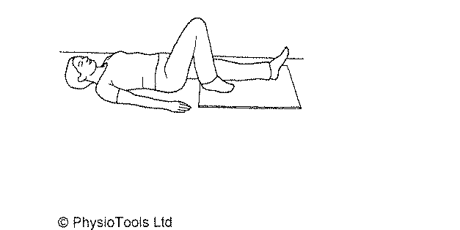

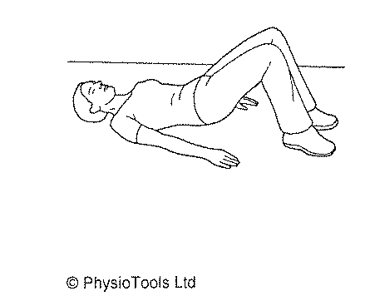Lie on your back with your knees bent and your feet on the floor. Lift your pelvis and lower back slowly by squeezing your bottom. Hold this position for 10 seconds. Slowly return to the starting position.
Repeat 10 times.

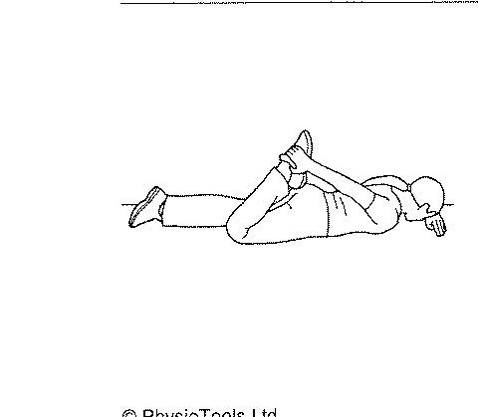Lie face down. Bend the knee of your operated leg and pull your ankle towards your bottom (if you are not able to reach your ankle, use a towel looped around your ankle to do this exercise). You will feel a stretch in the muscle on the front of your thigh. Hold this for 10 seconds then release the stretch.
Repeat this 10 times.

Lie on your back with a slippery surface under your leg (a plastic bin liner works well). Slide your leg out to the side and back to the centre. Be sure to keep your toes pointing to the ceiling throughout this exercise.
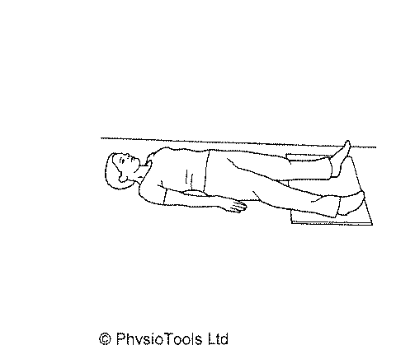Repeat 10 times

Sit down and place a ball between your knees. Squeeze the ball equally with both legs. Hold for 10 seconds.
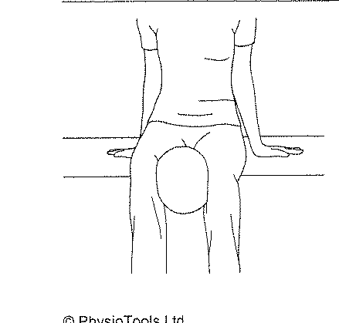Repeat 10 times

Stand upright supporting yourself with a solid surface (the kitchen work surface works well). Keep your trunk upright, tighten your but- tock muscles and slide your operated leg out behind yourself as far as is comfortable.
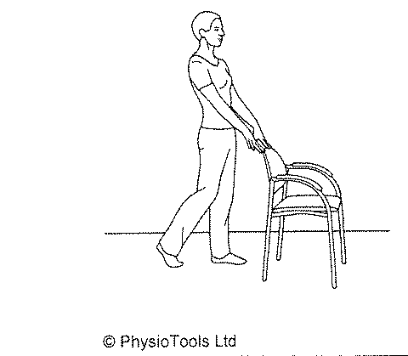Repeat this 10 times.

Begin these exercises 2 weeks after your operation

Lie on your back on a bed with both legs over the edge of the bed, your operated leg must be on the outside.
Use your arms to pull the non-operated knee towards your chest, allow the outside leg to hang gently over the edge of the bed. You will feel a stretch across the front of your hip joint and down your thigh. Hold this for 10 seconds.
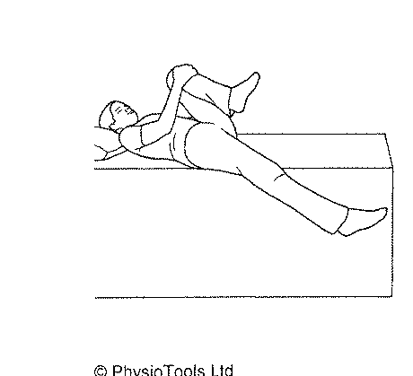Repeat 10 times.

NB: you must not bend your operated leg up during this exercise

Lie face down. Squeeze your buttocks firmly together and tighten your leg muscles. Keep your knees straight and lift your legs up off the floor. Hold for 10 seconds.
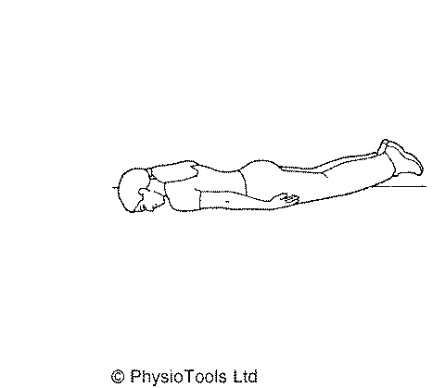Repeat 10 times.

Use a static bicycle to try cycling for 5 minutes without any resistance. When this is easy, increase the time you are cycling for in increments of 2.5 minutes. Only increase the time if you are easily achieving each level. When you are able to comfortably cycle for 20 minutes begin to gradually increase the resistance so that it is just a little challenging throughout the exercise session. Progressively increase the resistance as each level becomes easy. There is no set time for each increase, do this as you feel able
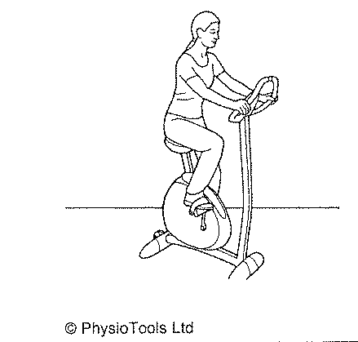

Intermediate Phase: 4-8 weeks

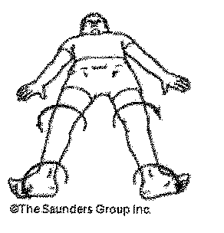Lie on your back with your legs apart. Turn your knees and toes outward as shown.
Repeat this 10 times.

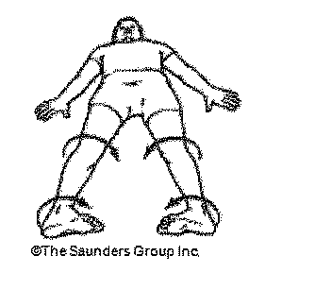Lie on your back with your legs apart. Turn your knees and toes inwards as shown.
Repeat this 5 times.

Lie on your back with your non-operated knee bent and your operated leg straight. Pull up the ankle of the operated leg, keep you r knee straight and lift your leg 20cms off the bed. Hold for 5 seconds and slowly lower to the starting position. Repeat 10 times.
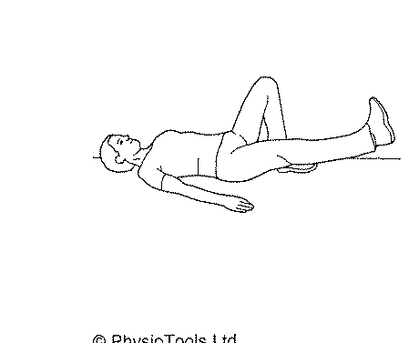

Lie on your side with your legs in a semi bent position and your operated leg upper most. Place a pillow/towel between your knees. Tighten your tummy and buttock muscles and lift the top leg up as far as you can without letting your pelvis move backwards. Keep your feet together and your back straight throughout this exercise. Lower your leg slowly to the starting posi-
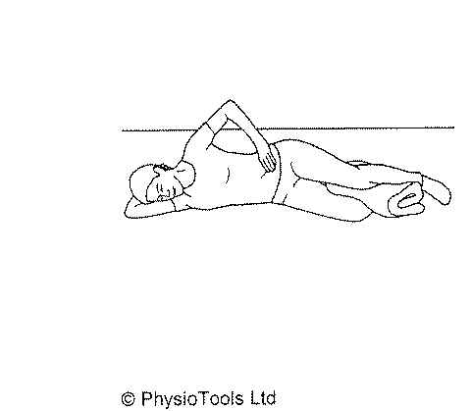

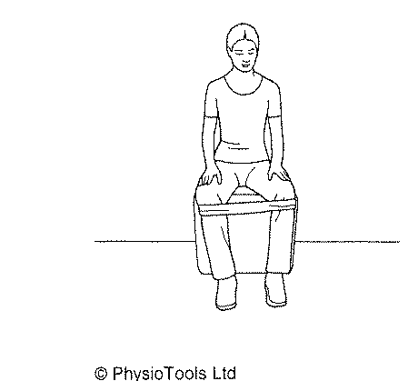Sit in a chair and place a rubber exercise band around your knees. Push your knees apart against the resistance of the band. Hold for 10 seconds then slowly return to the starting position.

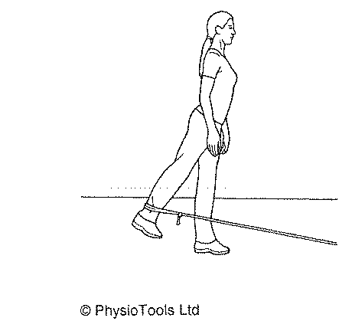Attach a loop of rubber exercise band to a solid object and place the loop around your ankle. Pull your leg backwards against the resistance of the band. Keep your trunk straight through out this exercise, do not lean forwards. Hold for 10 seconds then slowly return to the starting position.
Repeat 10 times

Sit on a large ball. Shift your body weight forwards, backwards and side to side, maintaining your balance throughout the movement. Keep your trunk upright throughout this exercise. Start with 1 minute and gradually increase the time to 5 minutes.

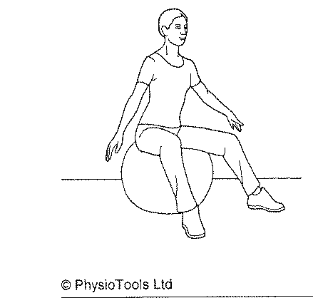

Adopt a half kneeling position with your operated leg at the back. Tighten your stom- ach muscles to keep your back straight. Rotate the heel behind you outwards whilst pushing your hip forward. Hold for 10 seconds.
Repeat 10 times.
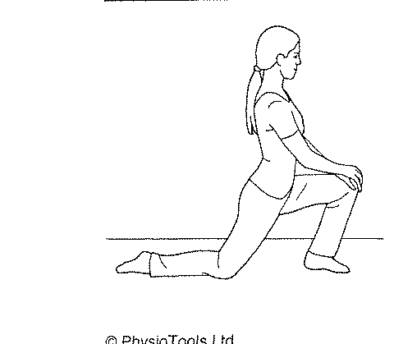

This exercise should be performed only after 6 weeks.
Sit with a band secured around the ankle of your operated leg. Bring your foot out towards the side, away from the mid line, against the resistance of the band then retrun to the starting posi- tion.
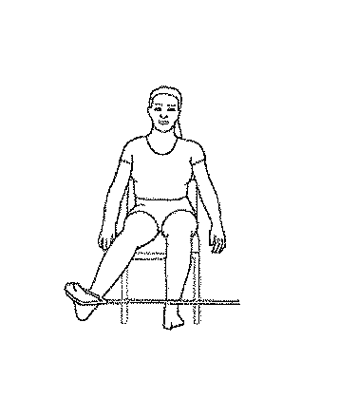Repeat 10 times.

This exercise should be performed only after 6 weeks.
Sit with a band around the ankle of your operated leg. Bring your foot up toward the opposite knee. Slowly return your foot to the starting position.
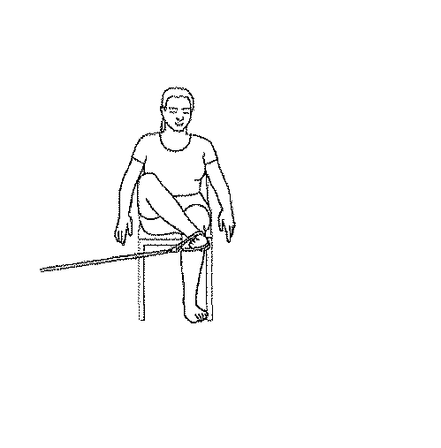Repeat 10 times.

Stand with your legs astride. Bend your non-operated leg and put your hands on this knee. Slide your operated leg out to the side just as far as is comfortable, then slide back to the starting position.
Repeat this 10 times.
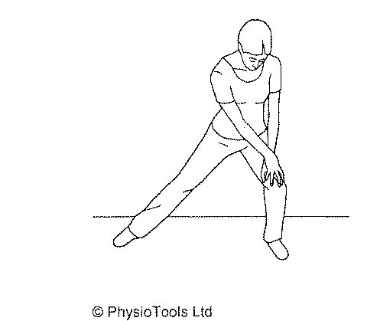

Attach a loop of rubber exercise band to a solid object, step into the band and pull it up around your knee on your operated leg. Stand with your knee slightly bent then straighten your knee, pulling against the band as you do so. Hold this for 10 seconds.
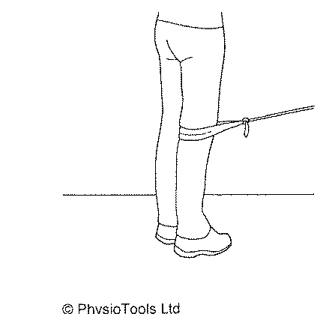Repeat 10 times

This exercise requires the use of a wobble board, so may only be possible in a gym. Stand with both feet centred on a circle wobble board. Keep the wobble board parallel to the ground. Keep your back and neck straight. Avoid over extending your knees.
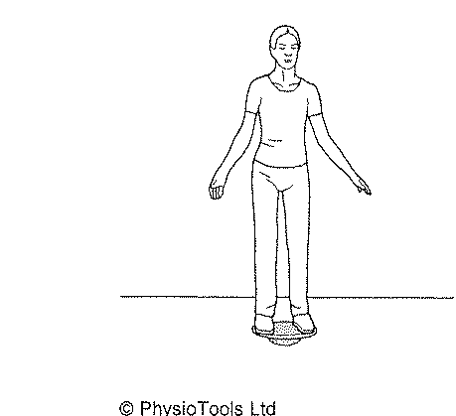Aim to hold this position for 30 seconds– 1 minute

Advanced Phase: 8-12 weeks

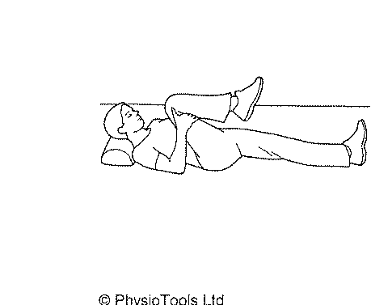Lie on your back. Bring your operated leg to your chest using your arms to help you. Pull your knee towards your chin, keeping your head on the pillow. You should feel a stretch through your buttocks and the back of your thigh. Hold for 10 seconds.
Repeat 10 times.

Lie on your side with your operated leg upper most. Bend your bottom leg for stability. Keep your top leg straight, bend up your ankle and lift this leg up with the heel leading. Do not let your pelvis roll forwards or backwards. Hold for 5 seconds then lower your leg slowly to the starting position.
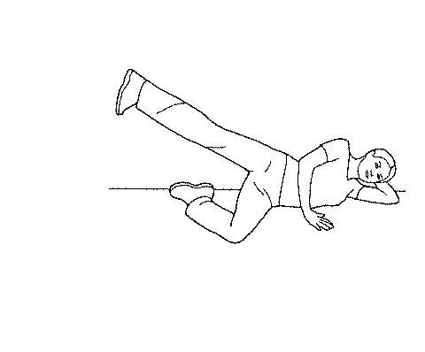Repeat 10 times.

- Lie on your back with your hands supporting your pelvis. Make a cycling movement with one leg 10 times. Repeat with the other leg.
- Lie on your back with your hands supporting your pelvis. Make a cycling movement with both legs for 1 minute. Try to gradually increase the time you do this up to 5 minutes.
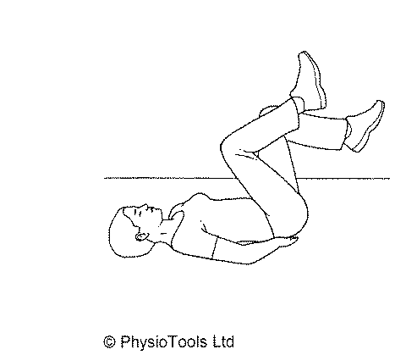

Lie on your back with your knees bent. Lift your hips up and be sure to keep your pelvis level. Try to straighten your knees alternatively whilst maintaining a level pelvis.
Repeat 10 times.

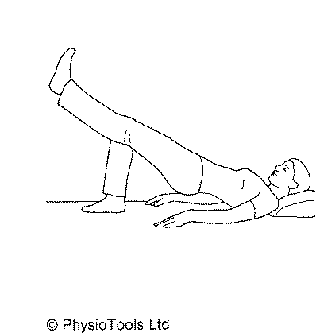

Lie on your side with your knees bent. Support your bodyweight on your fore- arm and knee. Tighten your stomach muscles and lift your hips off the surface. Keep your neck and back straight. Hold for 5 seconds.
Repeat 10 times on each side.
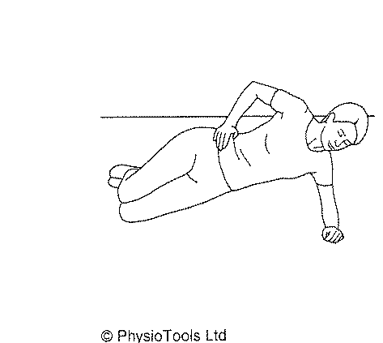

Lie on your back with your back with your knees bent and your hands clasped behind your neck. Lift your upper trunk by bringing your chin towards your chest and tightening your stomach muscles, then reach with your elbow towards your opposite knee, letting the knee come up a bit. Return to the starting position. Re- peat with the other side.
Repeat 10 times.
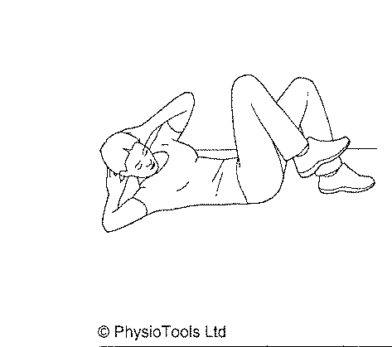

Rowing machine.
Start with 5 minutes and gradually increase the time as you are able up to 20 minutes. Thereafter, gradually increase the resistance within your own tolerance.

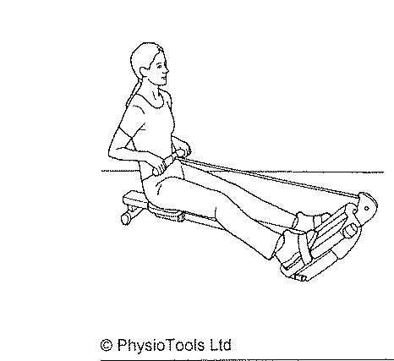

Stand against a wall with your feet 30cms from the wall and your knees slightly bent. Keep your back against the wall. Place a ball between your knees and squeeze into the resistance of the ball. Hold for 10 seconds.
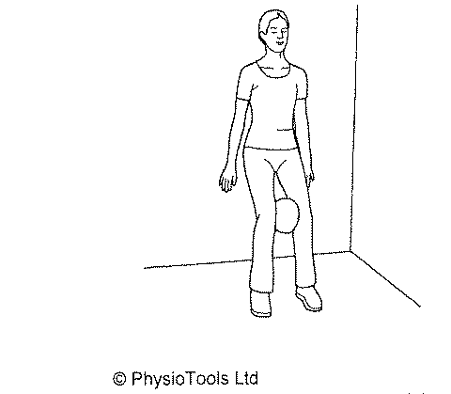Repeat 10 times.

Lie on your stomach on a large ball. Walk forward on your hands until your legs are on the ball then return to the starting position. Keep your trunk level throughout.
Repeat 10 times.

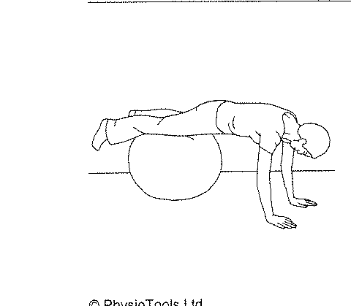

Lie on your back with your feet on a ball. Tighten your stomach and buttock muscles. Lift your pelvis and lower back off the floor. Hold for 5 seconds the slowly return to the starting position.
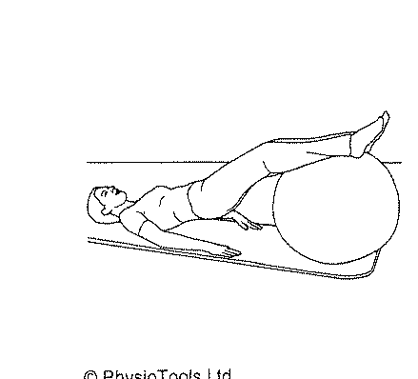Repeat 10 times.

Lie on your back on a ball with your knees bent and feet on the floor. Curl up and at the same time tighten your stomach and pelvic floor muscles.
Repeat 10 times.

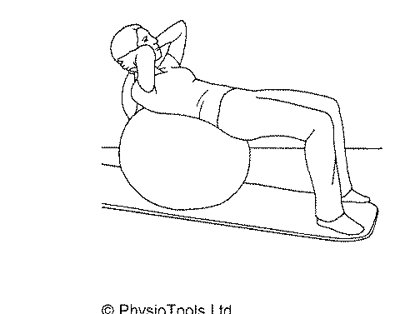

Stand holding a skipping rope and skip with both legs together. Try to build up to 1 minute.
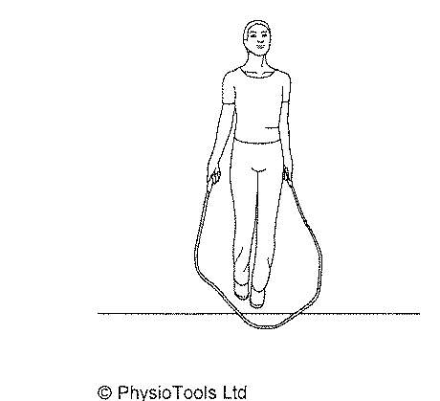Increase this as directed by your physiotherapist.

Sit on a bench or on the floor with your legs together and your knees bent. You can keep your arms out to the side for balance. Twist your knees from side to side. Do not let your feet touch the floor.
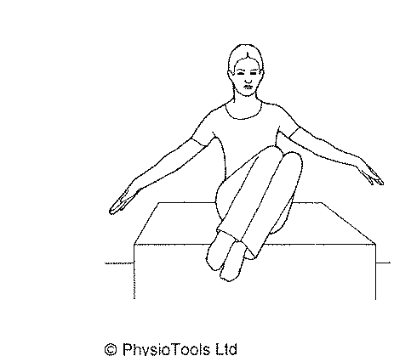Repeat 10 times.

In standing, slowly lean your body forward to 45 degrees. At the same time straighten one leg behind you and slightly bend the leg you are standing on. Keep your back straight and do not let your pelvis tilt.
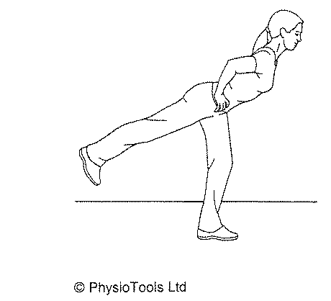Rep

Information
Please be aware that this handout is to be used as a guide. If you find these exercises painful please seek advise from your physiotherapist or doctor.

Notes:

